CPSC 473 - Front-End Engineering - Spring 2018

**Rate My Band**

**Installation and Configuration Guide**

By Swapnil Katkar, Kelly Nguyen, Snehal Maske, Aditi Patil, Scott Tran, Bernard Do

**Introduction**

Welcome to Rate My Band! This guide is intended to help the user configure the Rate My Band backend. It covers everything the user needs to know in order to get Rate My Band up and running.

Table of Contents

|  |  |
| --- | --- |
| 1. Description of Backend Collections: USERS | 3 |
| 2. Description of Backend Collections: USER-COMMENTS | 5 |
| 3. Description of Backend Collections: VIDEOS | 7 |
| 4. Changing the Server URL | 10 |

**The Rate My Band Backend**

Let’s begin by connecting our application to a backend. Rate My Band requires a backend with the following collections: USER-COMMENTS, USERS, and VIDEOS.

**1. Description of Backend Collections: USERS**

Attributes of the USERS Collection:

i. id  
The id attribute is a unique descriptor for the user.

ii. username  
The username attribute is used to login, along with the corresponding password.

iii. password  
The password attribute is used to login, along with the username attribute.

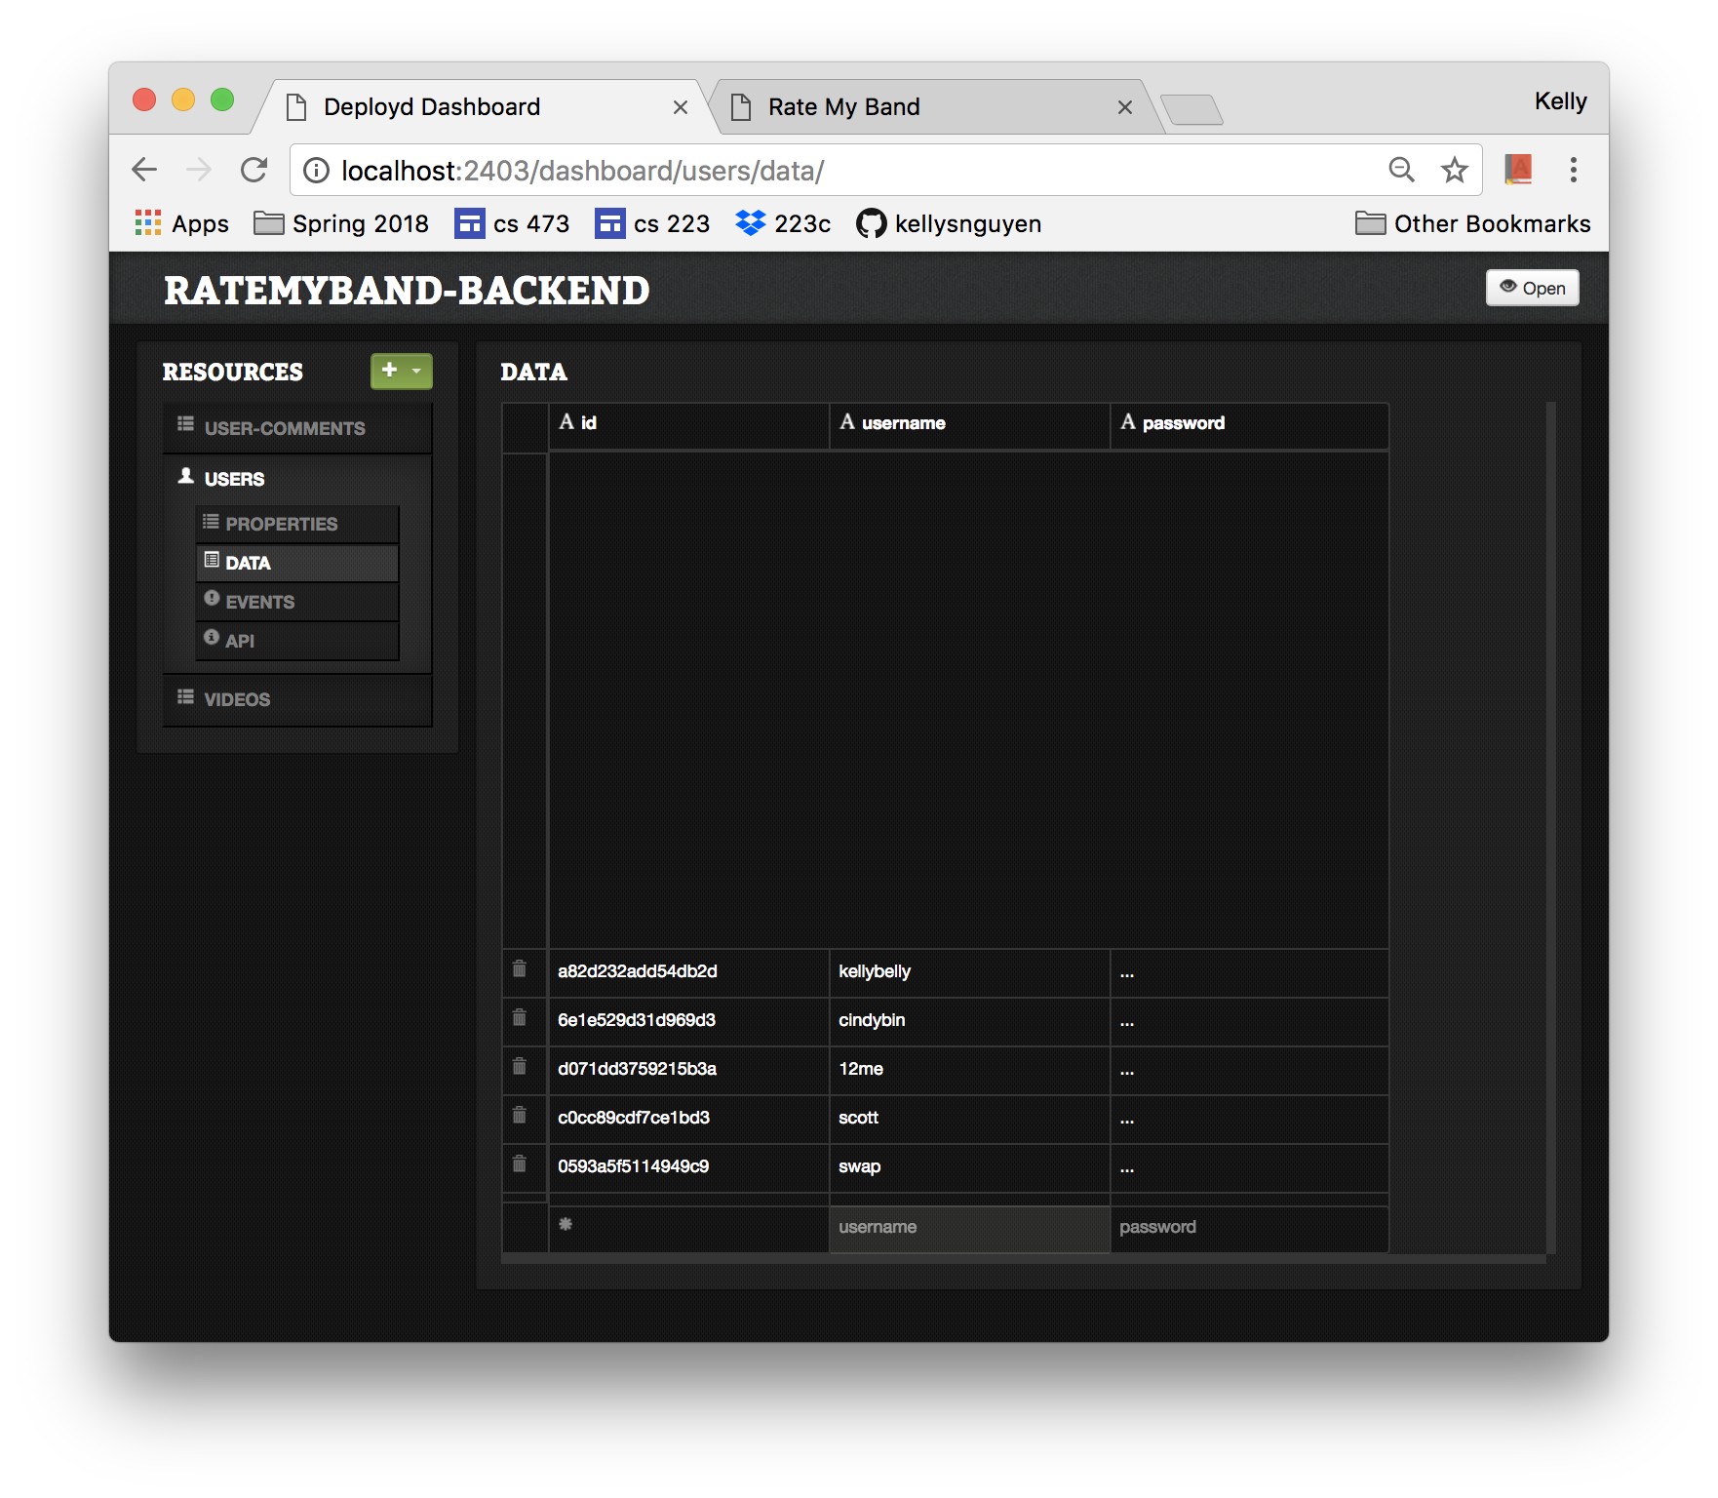

**2. Description of Backend Collections: USER-COMMENTS**

The USER-COMMENTS collection holds the data for all the comments on Rate My Band. The comments are assigned to videos using the videoId attribute.

Attributes of the USER-COMMENTS collection:

i. id

The id is a unique identifier for the comment

ii. username

The username attribute describes the user that submitted the comment. It is used to display the comment on the Rate My Band comments page.

iii. comment

The comment attribute holds the comment data. It is used to display the comment on the Rate My Band comments page.

iv. vote

The vote attribute holds the user’s vote that is accepted along with the comment. It is used to calculate the total vote count for that video on the Rate My Band comments page.

v. videoId

The videoId attribute is used to match the comment to its video

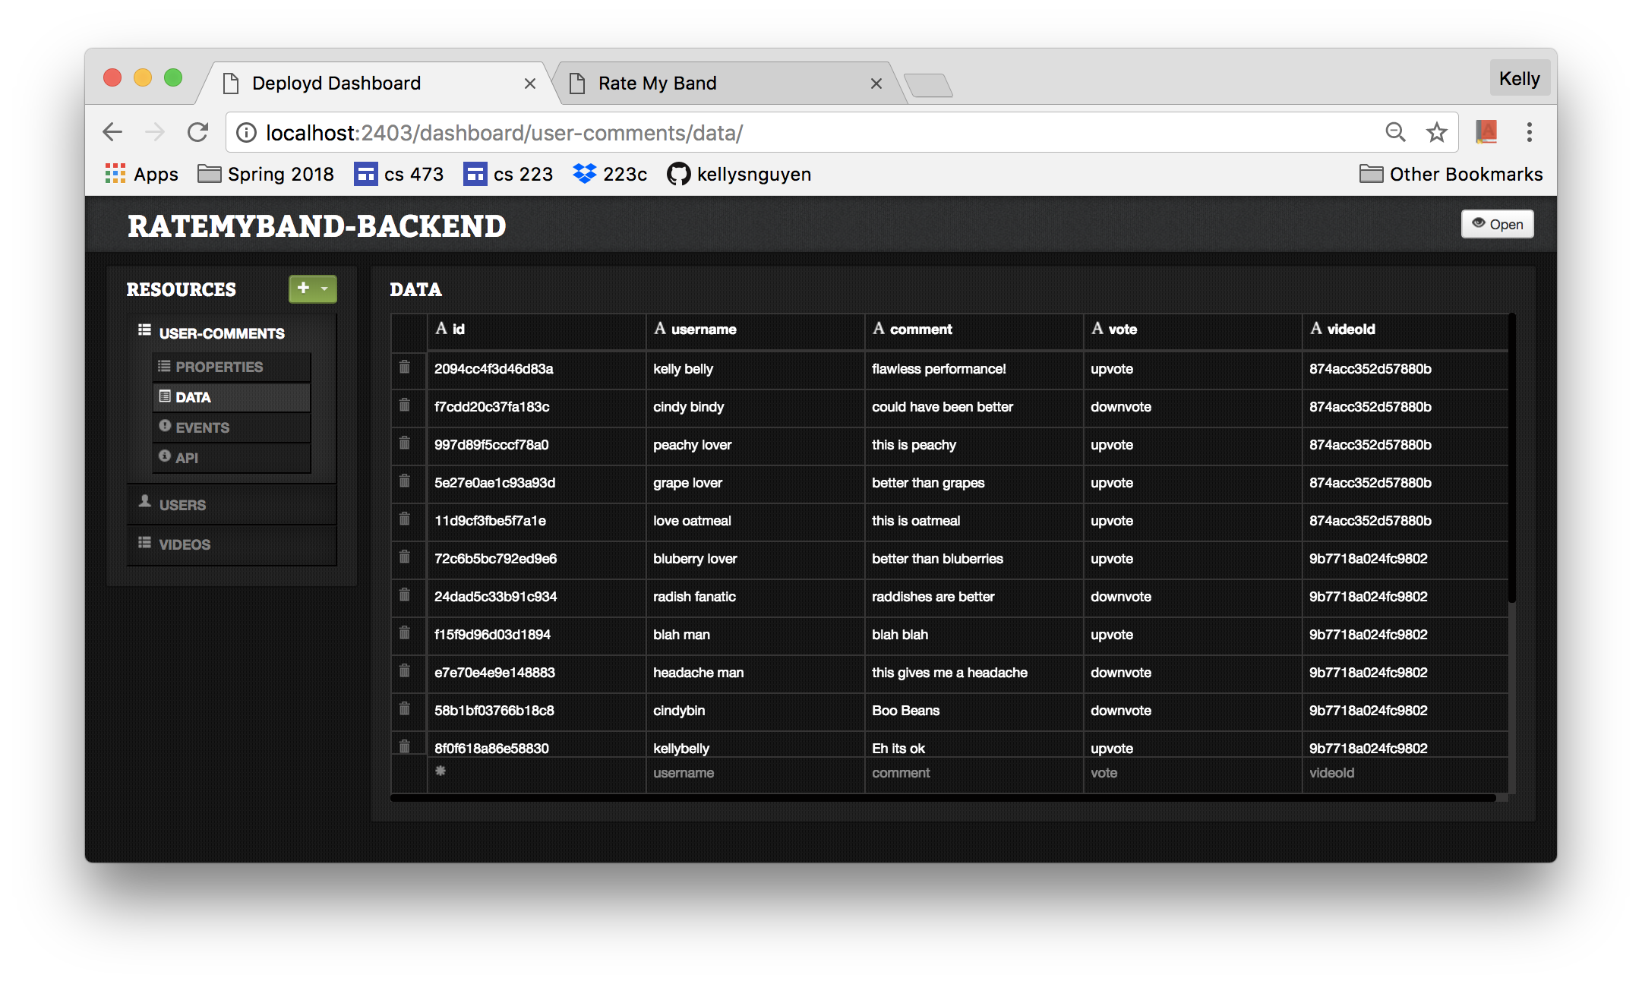

**3. Description of Backend Collections: VIDEOS**

The VIDEOS collection holds all the videos uploaded by users.

Attributes of VIDEOS collection:

i. id  
The id attribute is used by the Rate My Band comments page to display the video, video comments, band name, and performance location corresponding to the video that the user clicked on the home page.

ii. videoLink  
The videoLink attribute is the embedded link. The user needs to generate this link. Instructions on one way to do this are in section 4a.

iii. bandName  
The bandName attribute describes the name of the band in the video.

iv. performanceDate  
The performanceDate attribute describes the date of the performance.

v. performanceLocation  
The performanceLocation attribute describes the location of the performance.

vi. genre  
The genre attribute is used to sort the video on the Rate My Band home page.

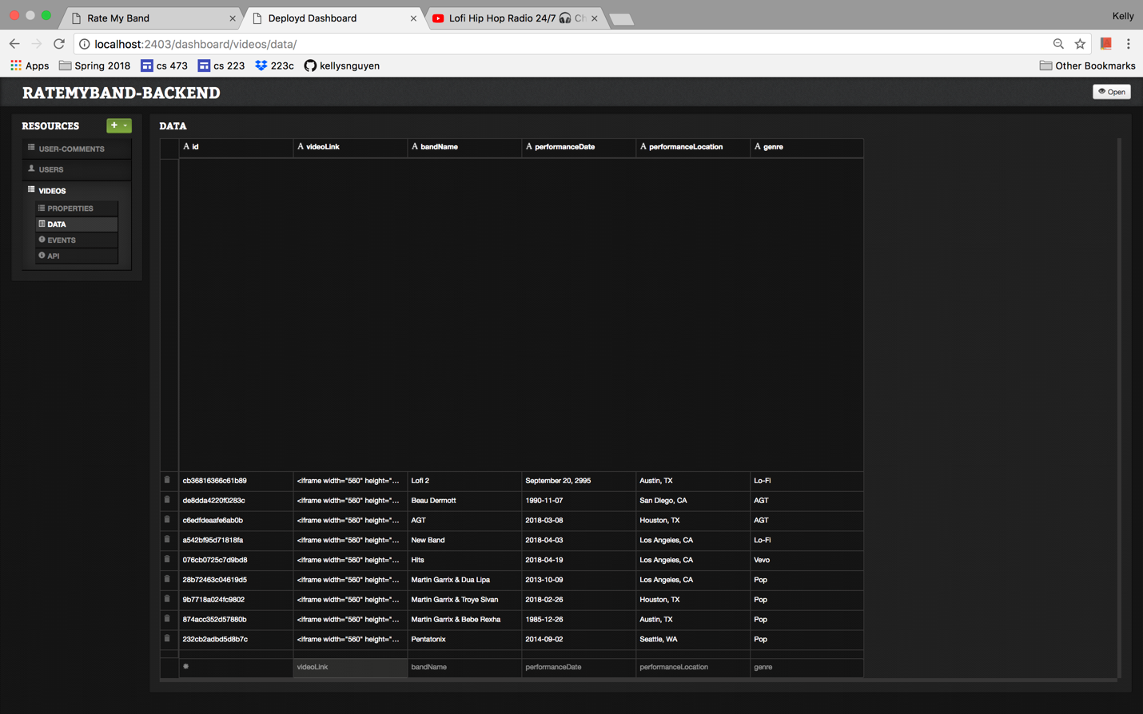

**4. Changing the Server URL**